Table 3: ADME Properties of selected COVID-19 major protease inhibitors

Compound | ADME Properties (Lipinki’s Rule of Five)
Compound | Properties | Value
Barleriaquinone I  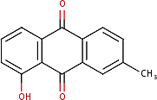 | Molecular weight (<500Da) | 238.24 g/mol
 | LogP (<5) | 2.73
 | H-Bond donor (5) | 1
 | H-bond acceptor (<10) | 3
 | Violations | 0 violation
Tectoquinone  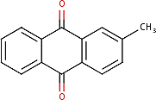 | Molecular weight (<500Da) | 222.24 g/mol
 | LogP (<5) | 3.01
 | H-Bond donor (5) | 0
 | H-bond acceptor (<10) | 2
 | Violations | 0 violation
Deoxylapachol  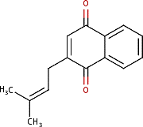 | Molecular weight (<500Da) | 226.27 g/mol
 | LogP (<5) | 3.13
 | H-Bond donor (5) | 0
 | H-bond acceptor (<10) | 2
 | Violations | 0 violation
Quercetin  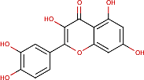 | Molecular weight (<500Da) | 302.24 g/mol
 | LogP (<5) | 1.23
 | H-Bond donor (5) | 5
 | H-bond acceptor (<10) | 7
 | Violations | 0 violation
Evofolin B  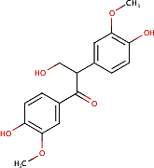 | Molecular weight (<500Da) | 318.32 g/mol
 | LogP (<5) | 1.87
 | H-Bond donor (5) | 3
 | H-bond acceptor (<10) | 6
 | Violations | 0 violation

Quinizarine  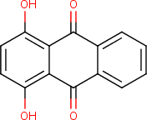 | Molecular weight (<500Da) | 240.21 g/mol
 | LogP (<5) | 2.15
 | H-Bond donor (5) | 2
 | H-bond acceptor (<10) | 4
 | Violations | 0 violation
Munjistin  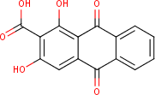 | Molecular weight (<500Da) | 284.22 g/mol
 | LogP (<5) | 1.53
 | H-Bond donor (5) | 3
 | H-bond acceptor (<10) | 6
 | Violations | 0 violation
Grandiquinone A  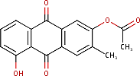 | Molecular weight (<500Da) | 296.27 g/mol
 | LogP (<5) | 2.62
 | H-Bond donor (5) | 1
 | H-bond acceptor (<10) | 5
 | Violations | 0 violation
Lapachol  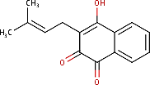 | Molecular weight (<500Da) | 242.27 g/mol
 | LogP (<5) | 2.54
 | H-Bond donor (5) | 1
 | H-bond acceptor (<10) | 3
 | Violations | 0 violation
4-Methylquinoline  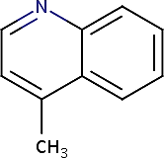 | Molecular weight (<500Da) | 143.19 g/mol
 | LogP (<5) | 2.45
 | H-Bond donor (5) | 0
 | H-bond acceptor (<10) | 1
 | Violations | 0 violation
Rubiadin  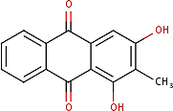 | Molecular weight (<500Da) | 254.24 g/mol
 | LogP (<5) | 2.23
 | H-Bond donor (5) | 2
 | H-bond acceptor (<10) | 4
 | Violations | 0 violation
Tecomaquinone-I  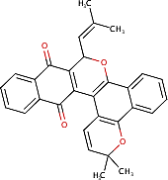 | Molecular weight (<500Da) | 448.51 g/mol
 | LogP (<5) | 5.55
 | H-Bond donor (5) | 0
 | H-bond acceptor (<10) | 4
 | Violations | 0 violation
Acetovanillone  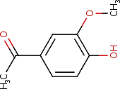 | Molecular weight (<500Da) | 166.17 g/mol
 | LogP (<5) | 1.28
 | H-Bond donor (5) | 1
 | H-bond acceptor (<10) | 3

 | Violations | 0 violation
Ellagic acid  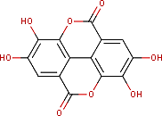 | Molecular weight (<500Da) | 302.19 g/mol
 | LogP (<5) | 1.00
 | H-Bond donor (5) | 4
 | H-bond acceptor (<10) | 8
 | Violations | 0 violation
Annuionone A  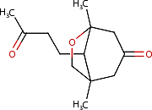 | Molecular weight (<500Da) | 224.30 g/mol
 | LogP (<5) | 1.81
 | H-Bond donor (5) | 0
 | H-bond acceptor (<10) | 3
 | Violations | 0 violation
Tectol  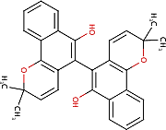 | Molecular weight (<500Da) | 450.53 g/mol
 | LogP (<5) | 5.94
 | H-Bond donor (5) | 2
 | H-bond acceptor (<10) | 4
 | Violations | 1 violation: MLOGP>4.15
Betulinaldehyde  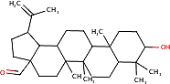 | Molecular weight (<500Da) | 440.70 g/mol
 | LogP (<5) | 6.39
 | H-Bond donor (5) | 1
 | H-bond acceptor (<10) | 2
 | Violations | 1 violation: MLOGP>4.15
Syringaresinol  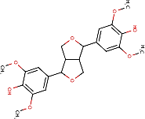 | Molecular weight (<500Da) | 418.44 g/mol
 | LogP (<5) | 2.33
 | H-Bond donor (5) | 2
 | H-bond acceptor (<10) | 8
 | Violations | 0 violation
Solidagonal acid  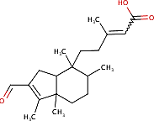 | Molecular weight (<500Da) | 318.45 g/mol
 | LogP (<5) | 4.15
 | H-Bond donor (5) | 1
 | H-bond acceptor (<10) | 3
 | Violations | 0 violation
Verbascoside  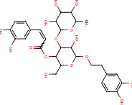 | Molecular weight (<500Da) | 624.59 g/mol
 | LogP (<5) | -0.43
 | H-Bond donor (5) | 9
 | H-bond acceptor (<10) | 15
 | Violations | 3 violations: MW>500,  NorO>10, NHorOH>5
Medioresinol | Molecular weight (<500Da) | 388.41 g/mol
Medioresinol | LogP (<5) | 2.33

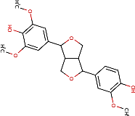 | H-Bond donor (5) | 2
 | H-bond acceptor (<10) | 7
 | Violations | 0 violation
Phytol | Molecular weight (<500Da) | 296.53 g/mol
 | LogP (<5) | 6.22
 | H-Bond donor (5) | 1
 | H-bond acceptor (<10) | 1
 | Violations | 1 violation: MLOGP>4.15
Lariciresinol  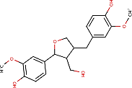 | Molecular weight (<500Da) | 360.40 g/mol
 | LogP (<5) | 2.38
 | H-Bond donor (5) | 3
 | H-bond acceptor (<10) | 6
 | Violations | 0 violation
Rhinocerotinoic acid  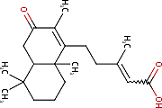 | Molecular weight (<500Da) | 318.45 g/mol
 | LogP (<5) | 4.16
 | H-Bond donor (5) | 1
 | H-bond acceptor (<10) | 3
 | Violations | 0 violation
Lupeol  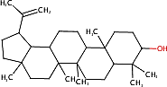 | Molecular weight (<500Da) | 426.72 g/mol
 | LogP (<5) | 7.31
 | H-Bond donor (5) | 1
 | H-bond acceptor (<10) | 1
 | Violations | 1 violation: MLOGP>4.15
Betulinic acid  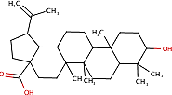 | Molecular weight (<500Da) | 456.70 g/mol
 | LogP (<5) | 6.11
 | H-Bond donor (5) | 2
 | H-bond acceptor (<10) | 3
 | Violations | 1 violation: MLOGP>4.15
Rutin  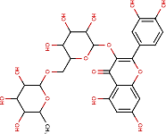 | Molecular weight (<500Da) | 610.52 g/mol
 | LogP (<5) | -1.12
 | H-Bond donor (5) | 10
 | H-bond acceptor (<10) | 16
 | Violations | 3 violations: MW>500,  NorO>10, NHorOH>5

